Practical 12: NotebookLM Project

Aim :-To create revision notes using NotebookLM.

Objectives
• To generate study guide
• To create flashcards

Materials Required
• NotebookLM

Procedure

1. Create NotebookLM project – Start a new project in NotebookLM to organize your materials and AI-generated outputs in one workspace.

2. Upload two resources – Add two documents or sources to the project so the AI can analyze and reference them.

3. Generate study guide – Use NotebookLM’s tools to create a structured study guide summarizing key concepts from the uploaded resources.

4. Generate flashcards – Automatically produce flashcards that highlight important facts, terms, or ideas for easier review.

5. Review accuracy – Carefully check the summaries and flashcards to ensure all information is correct and reflects the original resources.

6. Take screenshots – Capture screenshots of the study guide and flashcards to document your work or include them in your submission.

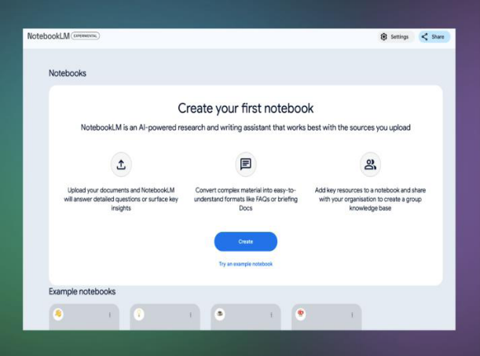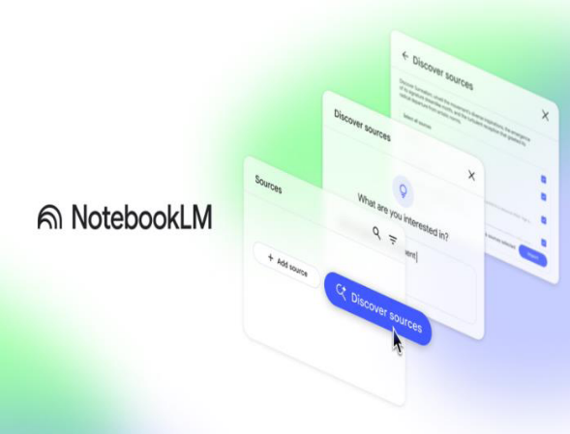
- Combined Study Guide (using all uploaded sources)
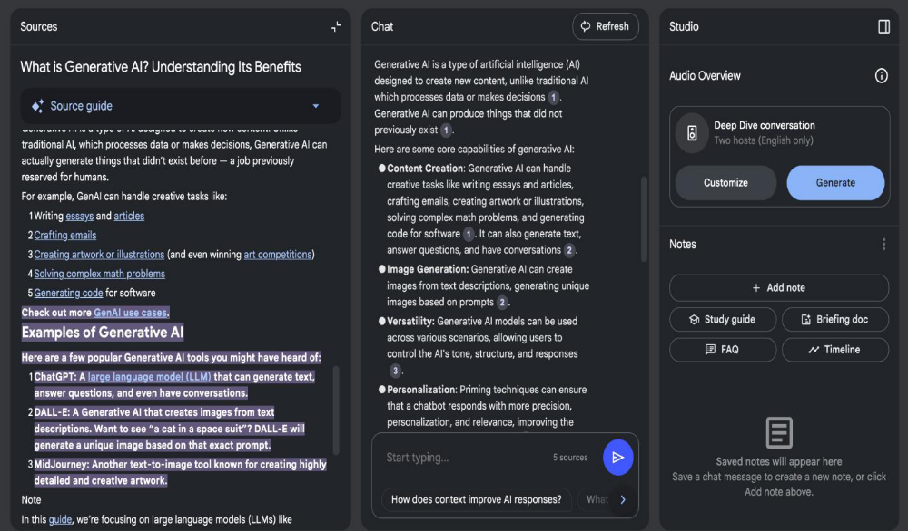

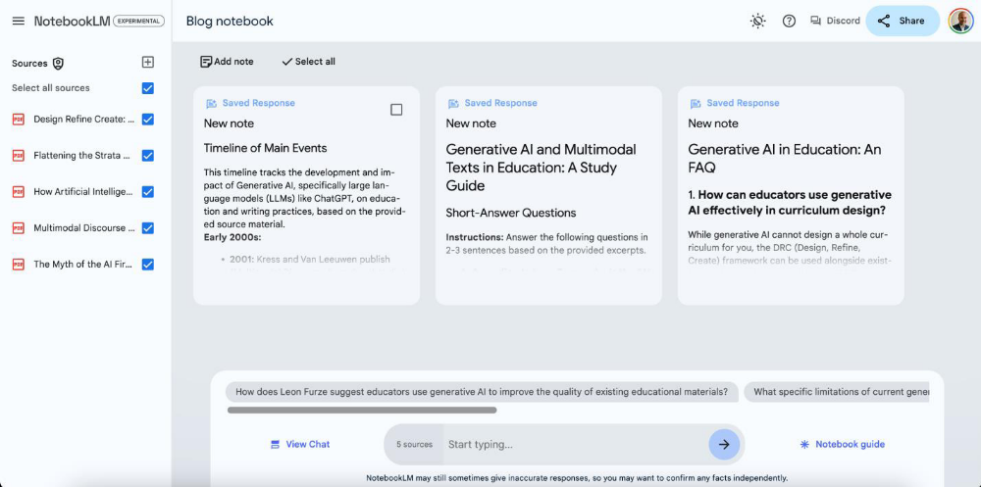
ii. Flashcards for Quick Revision
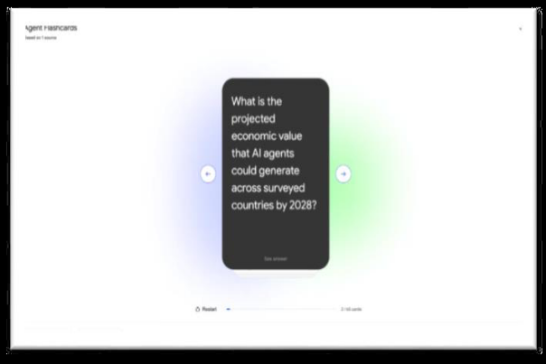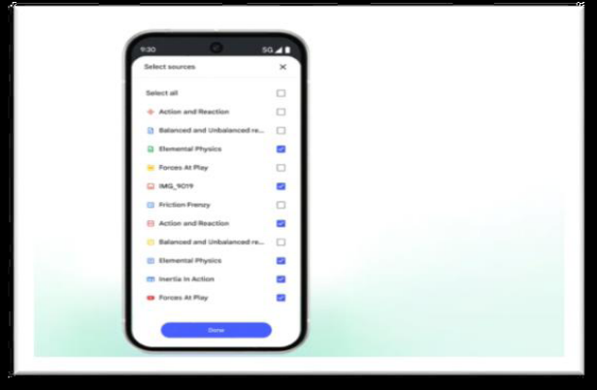
iii. Concept Map / Explanation of the Topic
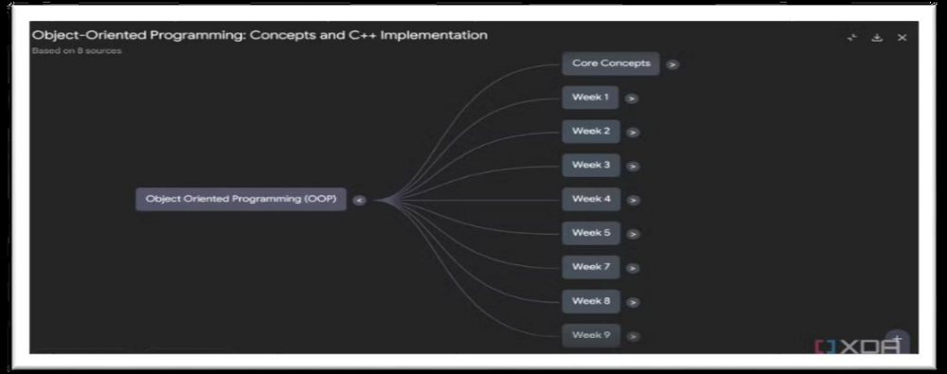
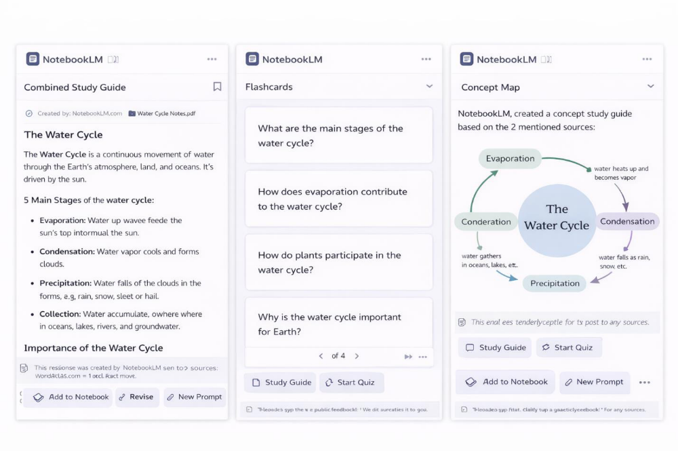
i. Any Incorrect Facts
• No major factual errors were found in the combined study guide.
• Definitions of key concepts were generally accurate and aligned with standard textbook explanations.
• Minor wording issues were observed, but they did not change the meaning of the concepts.

ii. Repeated Information
• Some repetition was noticed where the same definitions appeared in both the study guide and flashcards.
• Key ideas were restated in different sections, which is useful for revision but slightly repetitive in content.

iii. Missing Important Points
• Some advanced or real-life examples related to the topic were missing.
• The explanation could be improved by adding applications, limitations, or recent developments related to the topic.

